MS Excel tutorial provides basic and advanced concepts of Excel. Our Excel tutorial is designed for beginners and professionals by keeping their requirements in mind.

Microsoft Excel is a computer application program **written by Microsoft**. It mainly comprises tabs, groups of commands, and worksheets. It stores the data in tabular form and allows the users to perform manipulation operations on them.

Our MS Excel tutorial will cover all topics from basic to advance, such as Introduction of MS Excel, worksheets, ribbon and tabs, functions, formula, MS Excel online, Excel VBA editor, data validations, conditional formatting, and more. Along with it, we will also show you the steps to **download and activate MS Excel**.

What is Microsoft Excel?

Microsoft Excel is an office use application **designed by Microsoft**. It comes with **Office Suite**with several other Microsoft applications, such as Word, Powerpoint, Access, Outlook, and OneNote, etc. It is supported in Windows as well as Mac operating system too.

Microsoft Excel is one of the most suitable spreadsheet programs that help us to store and represent the data in tabular form, manage and manipulate data, create optically logical charts, and more. Excel provides you the worksheet to create a new document in it. You can save the Excel file with **.xls extension**.

Note: We are using Excel 2016 for this Excel tutorial.

Worksheet

A worksheet is made of rows and columns that intersect each other to form cells where data is entered. It is capable of performing multiple tasks like calculations, data analysis, and integrating data.

In Excel worksheet, **rows**are represented **by numbers** and **columns by alphabets**.

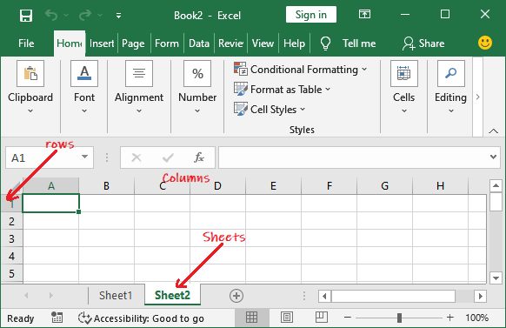

A single Excel workbook can consist of several sheets, named **Sheet1, Sheet2, Sheet3… SheetN**. You can add one or more sheets to your Excel document.

Microsoft Excel Features

There are several features that are available in Excel to make our task more manageable. Some of the main features are:

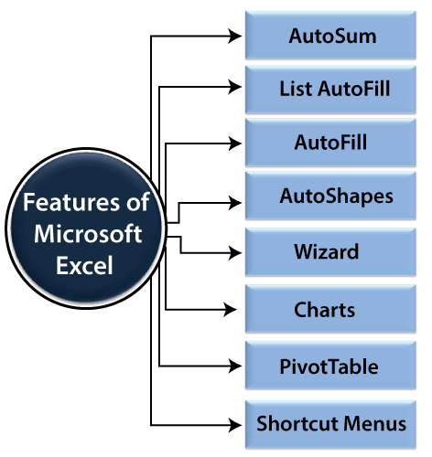

1. **AutoFormat:** It allows the Excel users to use predefined table formatting options.
2. **AutoSum:** AutoSum feature helps us to calculate the sum of a row or column automatically by inserting an addition formula for a range of cells.
3. **List AutoFill:** It automatically develops cell formatting when a new component is added to the end of a list.
4. **AutoFill:** This feature allows us to quickly fill cells with a repetitive or sequential record such as chronological dates or numbers and repeated documents. AutoFill can also be used to copy functions. We can also alter text and numbers with this feature.
5. **AutoShapes:** AutoShapes toolbar will allow us to draw some geometrical shapes, arrows, flowchart items, stars, and more. With these shapes, we can draw our graphs.
6. **Wizard:** It guides us to work effectively while we work by displaying several helpful tips and techniques based on what we are doing. Drag and Drop feature will help us to reposition the record and text by simply dragging the data with the help of the mouse.
7. **Charts:** This feature will help you to present the data in graphical form by using Pie, Bar, Line charts, and more.
8. **PivotTable:** It flips and sums data in seconds and allows us to execute data analysis and generating documents like periodic financial statements, statistical documents, etc. We can also analyse complex data relationships graphically.
9. **Shortcut Menus:** The shortcut menu helps users to make the work done through shortcut commands that need a lengthy process.

How to Open Microsoft Excel?

In Windows 10 operating system, click on the Start button and search for the MS Excel application. If it is already installed in your system, it will appear here like this.

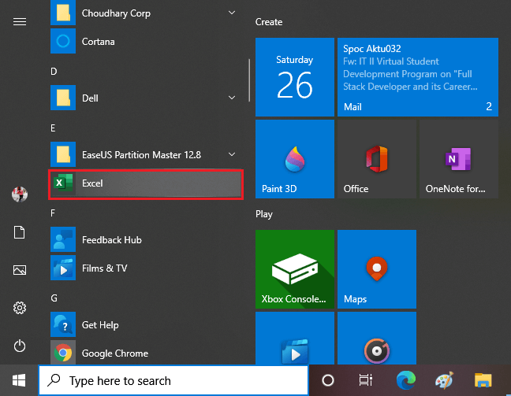

Double-tap on this icon to open the Excel.

When the Excel opens, an interface will appear like this. From here, you can create a new workbook, choose a template, and access your recently edited workbooks.

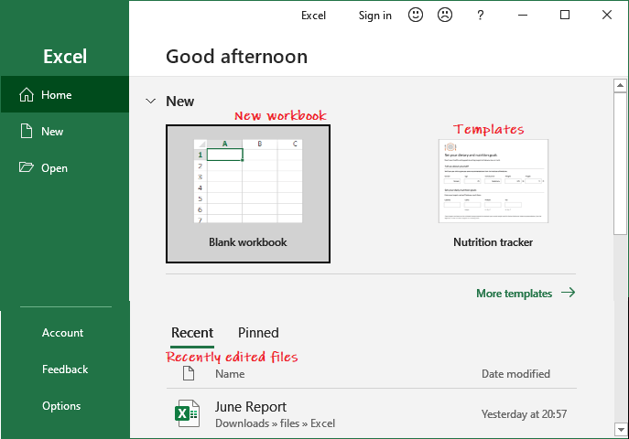

Create a new workbook

To create a new workbook, click on the **Blank Workbook** here.

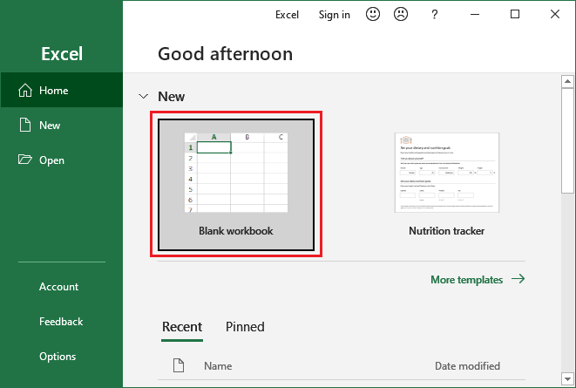

A blank Excel worksheet will open and display to you.

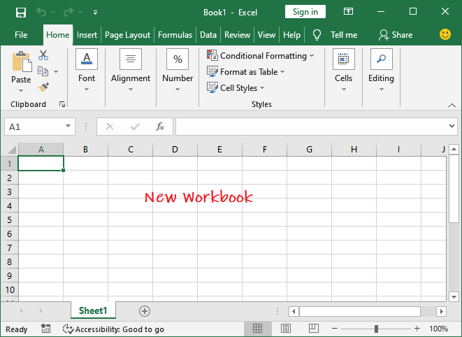

Open an existing workbook

If you want to work with an existing workbook, you can either choose from the **Recent** list or click on the **Open** button to select from the specific location.

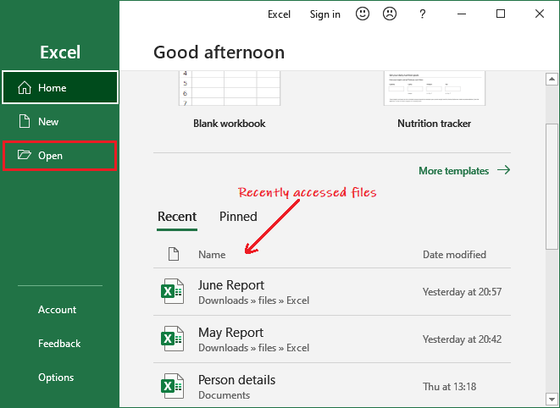

When you click the **Open** button, it will ask you to open the existing file from different locations, such as - **Recent, OneDrive, This PC,** and **Browse**.

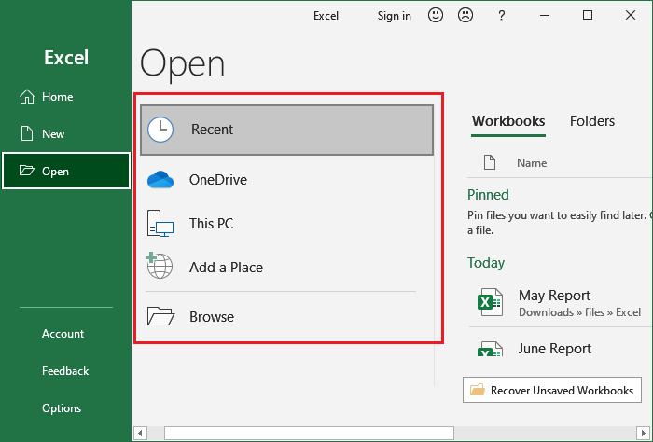

We will go for **Browse** this time; it will directly take you to the local computer location. From here, you can choose the Excel file you want to open.

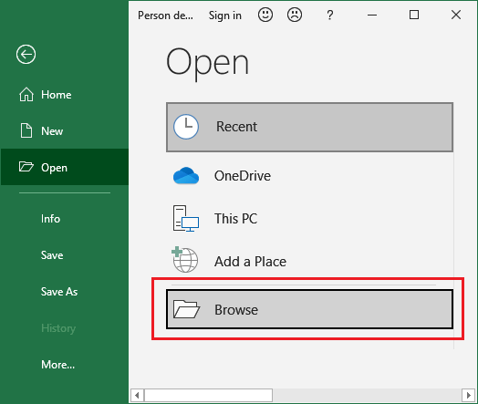

Choose a file from your computer and click on the **Open** button.

––––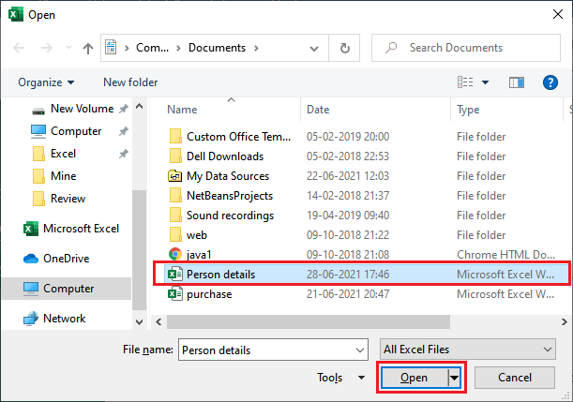

An existing Excel file that is stored on your local computer will open like this.

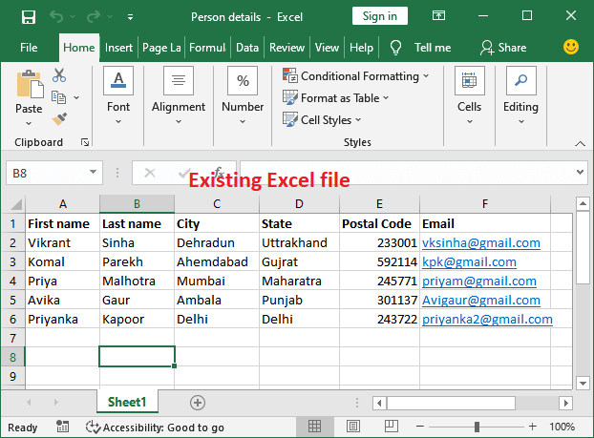

**Setup the option to open the blank workbook automatically**

In MS Excel, you can setup the option to open the blank Excel workbook by default whenever you start the Excel.

1. Click **File** then **Options** (Inside the **More…** in the right panel).
2. On the **General** tab, scroll down and go to the **Start up options**.
3. Here, uncheck the **Shows the Start screen when this program starts** checkbox and then click **OK**.  
   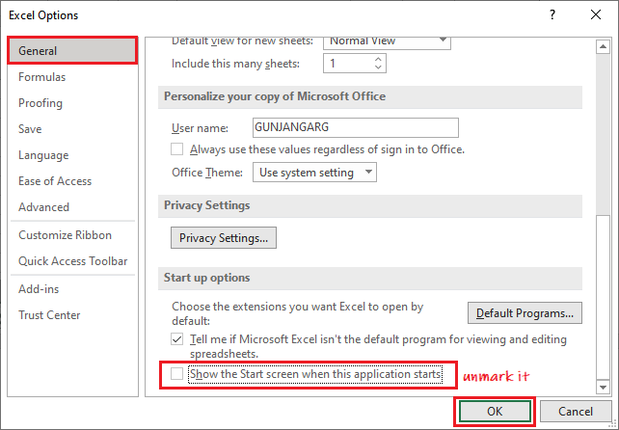
4. The next time you start Excel, it will open a blank workbook automatically.

Excel Interface

It is the main interface of an Excel worksheet, where we work and store our data. This interface contains various components. Before start working with Excel worksheet, you should be familiar with these components so that you can use the Excel application efficiently.

Once you get familiar with the Excel interface, you will able to identify the basic and most-used components of an Excel workbook. We have explained a bit about these components.

–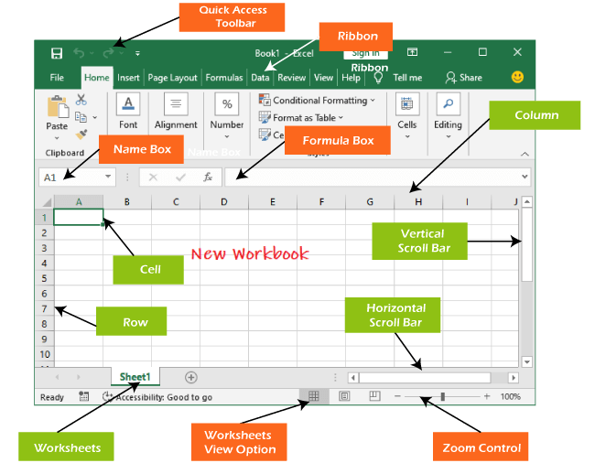

Quick Access Toolbar

The Quick Access Toolbar contains some common and most used commands of Excel, which users repeatedly need while working with Excel. By default, **Save, Undo**, and **Repeat** commands are added in the quick access toolbar.

It provides fast access to its users by adding most-used commands in it. This quick access toolbar is customizable. It means you can add other commands, whichever you need most.

**Add commands to the Quick Access toolbar**

**Step 1:** Click on the drop-down arrow to the right of the Quick Access toolbar.

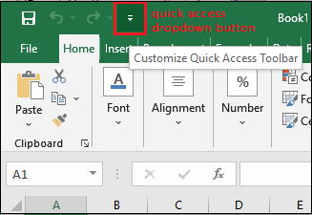

**Step 2:** Select the command you wish to add in the quick access toolbar from the drop-down menu.

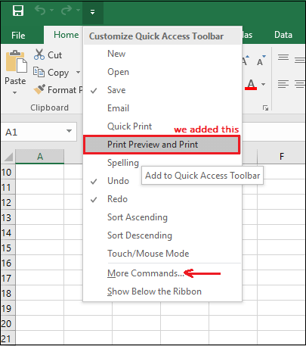

For more command, which is not available here, click on **More Commands** and choose from there.

**Step 3:** Here, we have selected command **Print Preview and Print** that has been added to the Quick Access toolbar along with other commands. You can see it here.

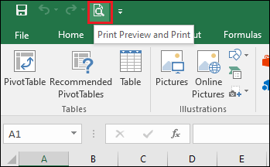

Excel Ribbon

Excel 2016 utilizes a **tabbed Ribbon system** instead of traditional menus. The **Ribbon** includes multiple tabs, each with several **groups of commands**. We will use these tabs to perform the most common function in Excel.

**File, Home, Insert, Page Layout, Formula, Data, Review, View,** and **Help** are the tabs consists by the Excel ribbon.

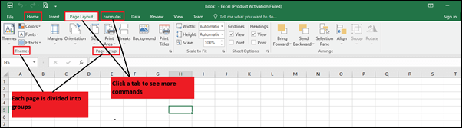

Each tab of Excel Ribbon contains its related operations list. **For example**, the formula tab contains all the mathematical, logical, text, string, finance, Date, and time functions.

**To minimize and maximize the Ribbon**

The Ribbon is designed to respond to our current function, but we can choose to minimize it if we find that it takes up too much screen space.

1. To click the Ribbon Display Options arrow in the upper-right corner of the Ribbon.  
   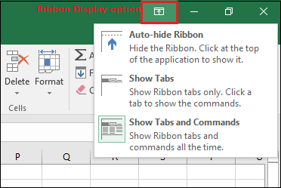
2. Select the desired minimizing options from the drop-down menu:
   * **Auto-hide Ribbon:** Auto-hide shows our workbook in full-screen mode and hides the Ribbon completely. To **show the Ribbon**, click **Expand Ribbon** command at the top of the screen.  
     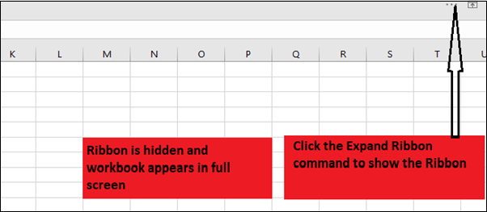
   * **Show Tabs:** This option hides all command groups when not in use, but **tabs** will remain there. To **show the Ribbon**, simply click on any of the tabs.  
     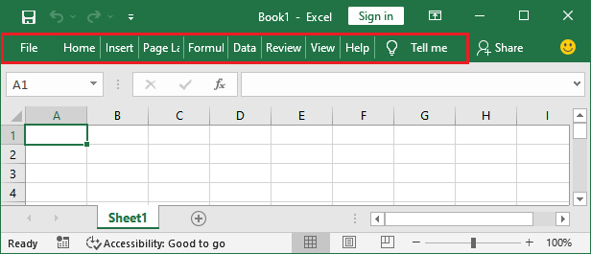
   * **Show Tabs and Commands:** This option maximizes the Ribbon. All of the tabs and commands will always be visible to the user. This option is selected by default when we open Excel for the first time.  
     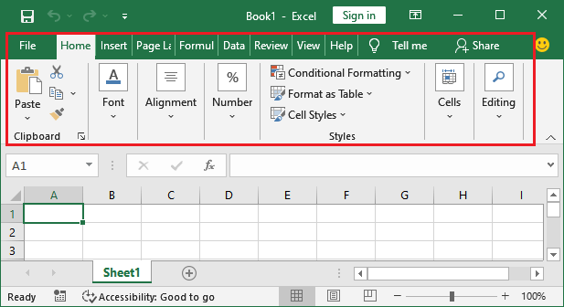

To Customize the Ribbon in Excel 2016

We can customize the Ribbon by creating our own **tabs** with whichever commands we want. Commands are always housed within a **group**, and we can create as many groups as we want to keep our tab organized. If we want, we can even add commands to any of the default tabs, as long as we create a custom group in the tab.

If we want, we can even add commands to any of the default tabs, as long as we create a custom group in the tab.

1. Right-click the **Ribbon** and then choose **Customize** the Ribbon from the drop-down menu.  
   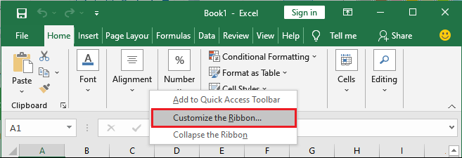
2. The **Excel Options**dialog box will occur. Locate and select **New Tab** or **New group**, whichever you want to add.  
   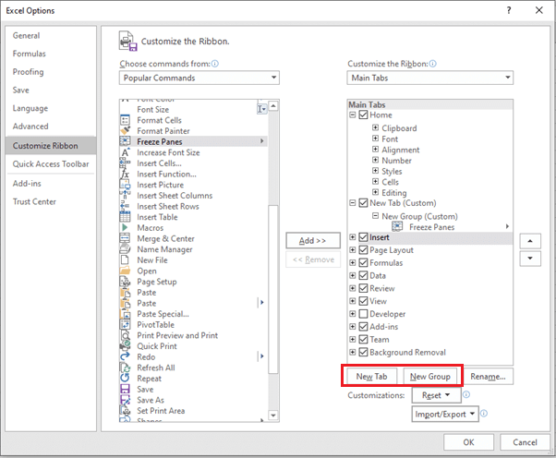
3. Now, select a command from the left panel and click the Add button to the new customized tab/group. You can also drag the commands directly into a group.  
   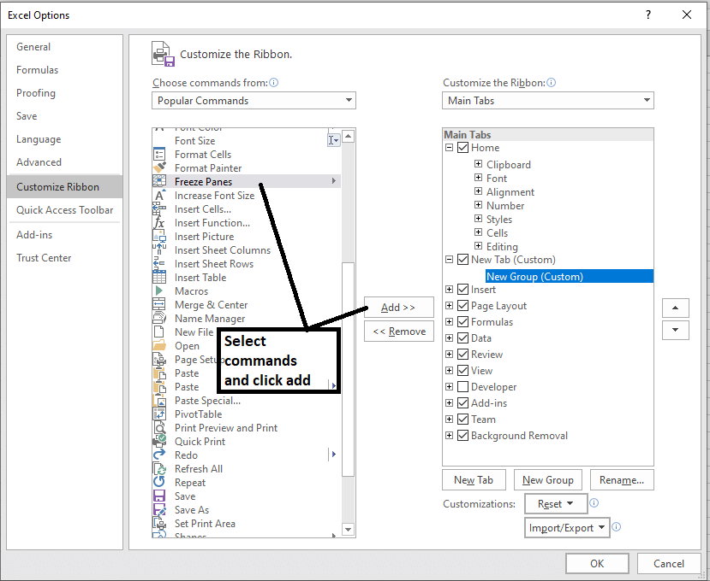
4. When you are done adding commands, click OK. The commands will be added to the Ribbon in a new tab like this.  
   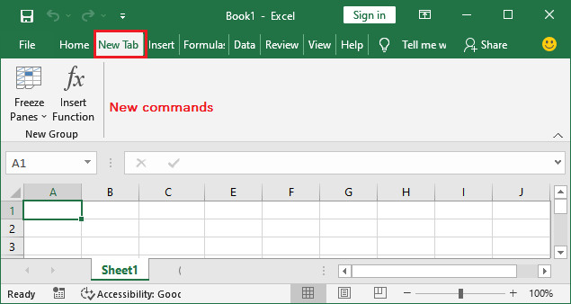

Note: You can also rename the tab and group name.

Formula Bar

In the **formula bar**, we can enter or edit data, a formula, or a function that will occur in a specific cell. It allows to write the function and formulas to manipulate the data.

In the image below, cell C1 is selected, and 2000 is entered into the formula bar. Note how the data contains in both the formula bar and in cell C1.

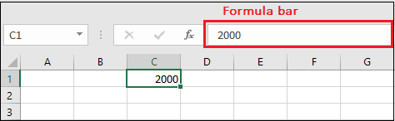

Name Box

The Name box presents the location or **"name"** of a **selected cell**.

In the image below, cell B4 is selected. Noted that cell B4 is where column B and row 4 intersect.

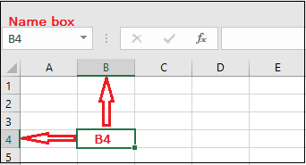

The Backstage View (The File Menu)

Click the **File** tab on the Ribbon. The **Backstage view** will emerge.

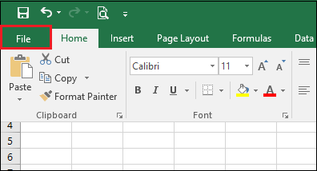

It is the backstage view of MS Excel and information about the options it contains.

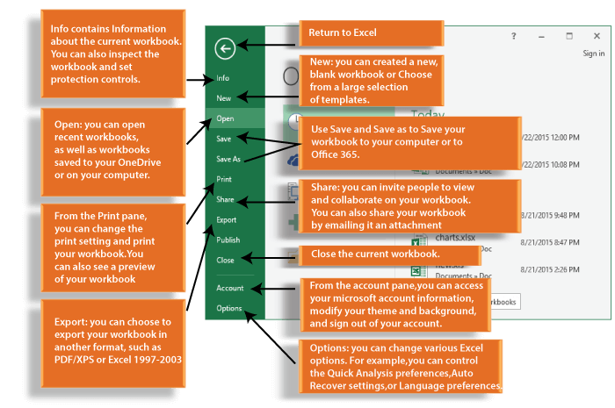

The Worksheet Views

Excel 2016 has a variety of displaying options that change how our workbook is showed. We can choose to view any workbook in the **Normal view, Page Layout view,** or **Page Break view**. These views can be useful for several tasks, especially if we're planning to **print** the spreadsheet.

To change the worksheet views, locate and choose the desired worksheet view command in the bottom-right corner of the Excel window.

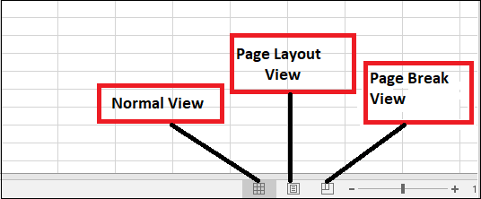

Zoom Control

To use a **Zoom control**, click and drag the **slider**. The number to the right of the slider reverse the **zoom percentage**. It presents at the bottom right corner of the Excel worksheet.

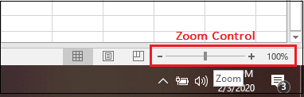

By default, Excel view zoom percent is 100%.

# **How to do addition in Excel**

One of the typical day-to-day operations performed in Excel is **addition.** Whether you have to find the sum of the price list, expense sheet, and calculate the total sales or any other action. You can even create your customized **SUM formulas** by combining the SUM function with other **Excel** functions.

Therefore, in this tutorial, we will cover the various ways to quickly calculate the sum of numbers in excel.

## 1. Sum a column in Excel with one click

This is one of the fastest options that is quickly used to find the sum of numbers. To apply this method, follow the below steps.

1. Click on the **column alphabet** for which you want to find out the sum.
2. At the **Excel Status** bar, you will notice **the total of the cells.**  
   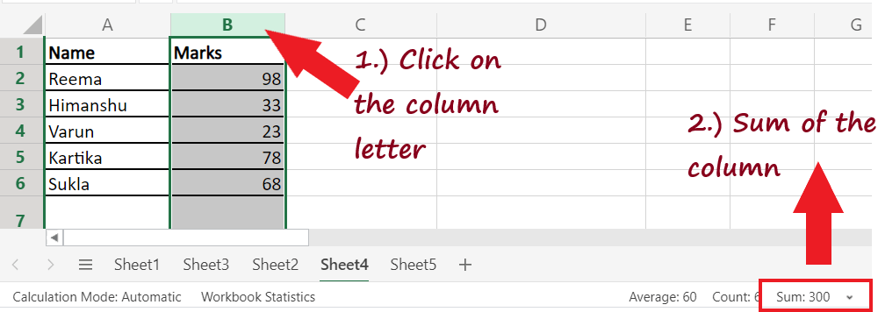
3. Instead of selecting the entire column, you can **select a few cells to calculate the sum.** It will quickly display the sum of the selected cells in the Excel status bar.

#### NOTE: Though this method is quick, the drawback of this method is that it neither allows copying nor shows numeric digits.

## 2. Calculate the sum in Excel with AutoSum

The second method down in your list is **AutoSum.** This method allows the user to **quickly sum up a column and hold the output in the table.** The advantage of using the AutoSum method is that it automatically adds up the numbers and will present the result in the specified cell. To apply this method, follow the below steps.

1. **Click on the empty cell** below the column where you want to sum up the numbers.

#### NOTE: To bypass any additional operations like range selection, always select the first empty cell below the column you require to sum.

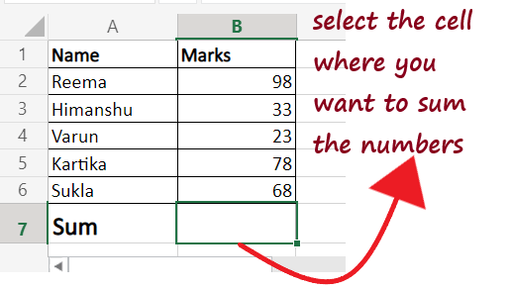

2. Go to the **Home tab -> Editing group -> AutoSum** option.

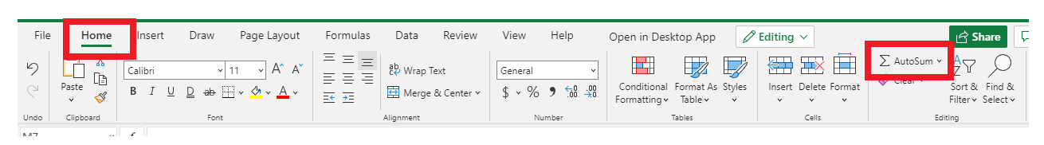

3. Excel will automatically **pick the range** and will put the same in the SUM function. Though if needed, you can alter the range as well.

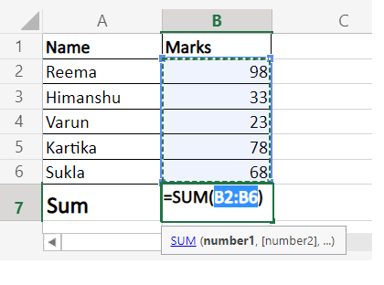

4. Click on the **Enter button** on your keyboard, and you will notice Excel will immediately give you the **sum of the numbers** present in the selected range.

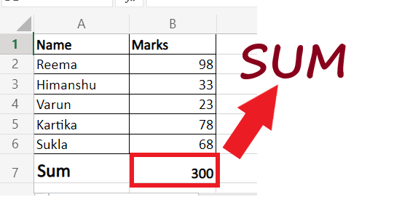

This method is fast and lets you automatically get and keep the summing result in your table.

## 3. Addition using the SUM function

One of the easy methods commonly used to find the total in Excel is the **SUM function.** The SUM function is used to select specific cells or even a large range in an Excel worksheet and calculate their total. This method is beneficial if you have a **large excel column and want to calculate the sum without highlighting the range.** Though, you still need to enter the SUM function manually.

#### NOTE: The SUM function calculates the sum of all the values selected in the range even if the cells are hidden or filtered.

Using the **SUM function** in Excel, you can find a range of cells, an entire column/row, contiguous cells, or even non-contiguous cells. Excel users often create customized advance functions by combining the SUM function with other **Excel** functions.

To apply this method, follow the below steps.

1. Click on the empty cell below the column where you want to sum up the numbers.

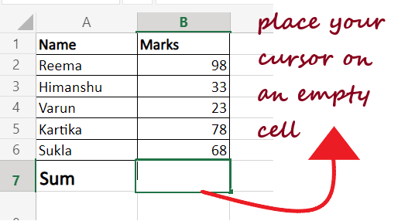

2. Start the formula with equal to **(=) followed by SUM ()**. In the arguments select the range of the cells by pointing your mouse to one cell and dragging the cursor to the end. If you want you can directly enter the number of cell references separated by comma.

#### NOTE: You can also manually type the SUM range address. It is helpful to calculate large range data easily. For example =SUM(D2:D3000).

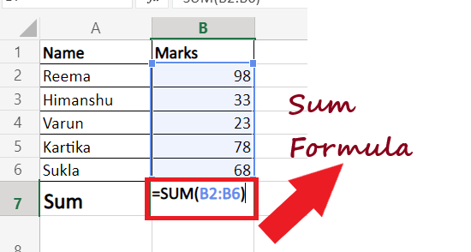

3. Press the **Enter button** and Excel will immediately calculate the sum of numbers.

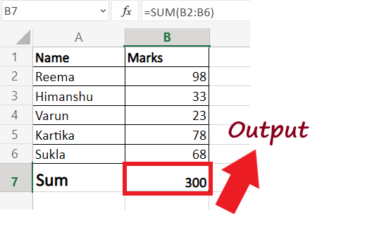

## 4. Find Sum of only visible cells

In the above section, we have covered that SUM functions add all the values, including the hidden and filtered fields. Therefore, with this method, we learn how to calculate the **sum only for the visible cells. Therefore, omitting the filtered or hidden cells.** To apply this method, follow the below steps.

1. Enter your data in Excel spreadsheet.  
   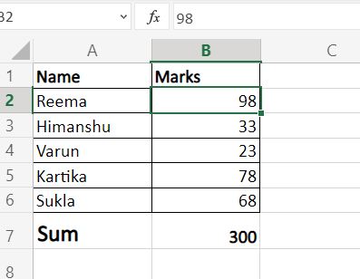
2. Now, we will filter the above dataset and fetch only the values that are greater than 40. Click on any cell and go to **Data-> Sort & Filter-> Filter icon.**  
   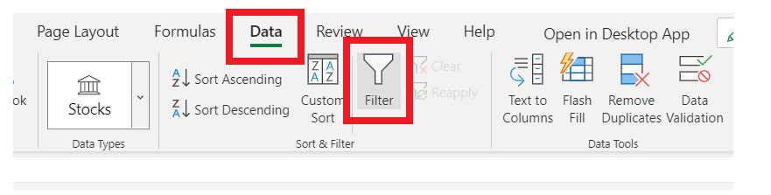
3. As shown below the filter arrows will appear in the header. Click on the **Marks filter arrow.**  
   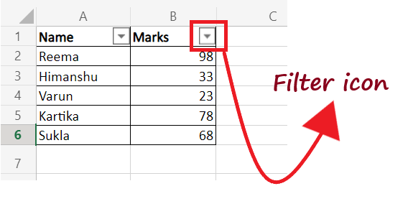
4. The following window will appear. Click on **Number Filters-> Greater than.**  
   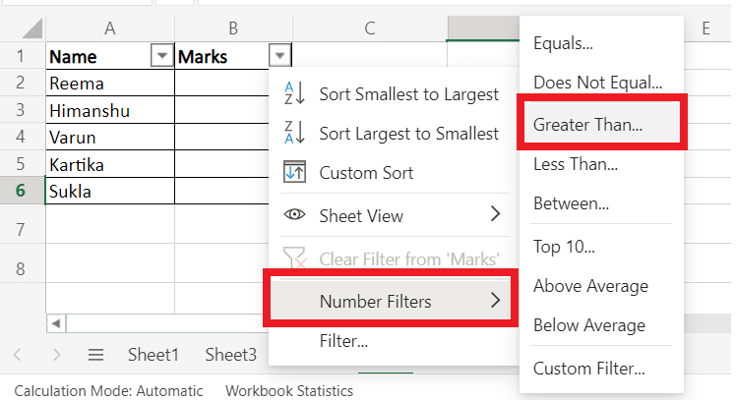
5. It will display the Custom Filter window. In the textbox, **type 40 and press ok.**  
   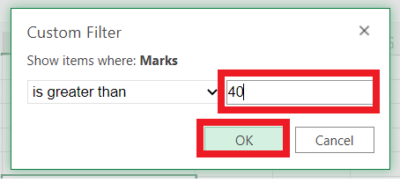
6. It will show you the following **filtered output.**  
   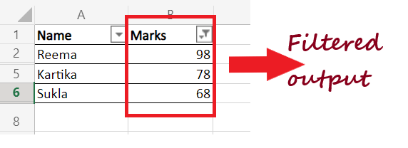
7. To quickly find the sum of the filtered column, select the range and click on **AutoSum** under the Home tab. You will have your **filtered sum** in the selected cell.  
   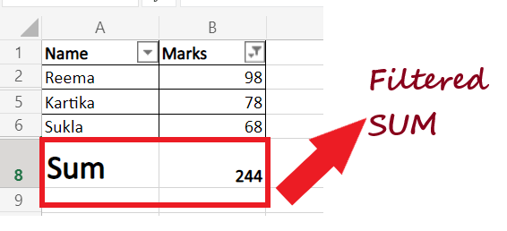
8. Another method to quickly find the sum is by selected the filtered cells and view the **sum of the cells** on the **Excel Status bar.** Though with this method, you won't be able to paste the data into your worksheet.

## 5. Convert data into Excel table and get the sum for your column

Creating tables and calculating the sum of the columns is also one of the common methods to find the sum. Therefore if you have a large dataset and want to find the sum, convert your data to Excel Table. It will be helpful to quickly total the sum of the columns and rows of your table. To apply this method, follow the below steps.

1. Put your cursor on any cell and press the shortcut key' Ctrl + T' on your keyboard to **create a table out of your Excel data.** You will have the given Create Table window and it will automatically select the data for you. Click on OK.  
   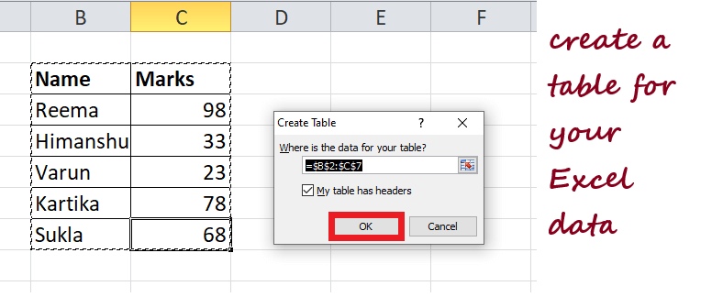
2. Excel will create a table for you. Next, in the ribbon toolbar, you will see the Design tab. Navigate to this tab and look for the Total Row. As shown below, **tick the checkbox** given in front of the **Total Row.**  
   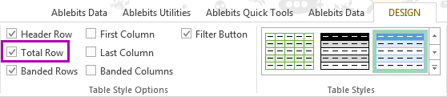
3. Excel will immediately **add a new row** (named with Total) at the end of your table. Though it already calculates the sum, still make sure to click on the small arrow icon next to your number.  
   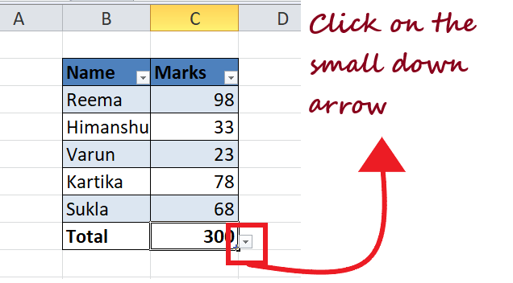
4. Select the **SUM option** from the appeared options. That's it you will get the **sum of your data.**  
   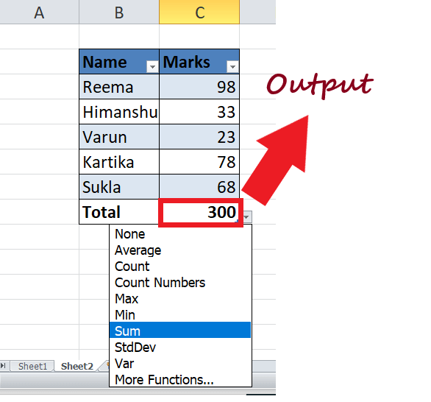
5. Using the method you can easily find the sum of every column. You can also try the other options as well such as Average, Min and Max.